MLA0105 - Artificial Intelligence and Expert Systems for Gaming
Exp-51: -Animlas and Habits
Code:
habitat(fish,water).
habitat(whale,water).
habitat(penguin,water).
habitat(crocodile,water).
habitat(dog,land).
habitat(cat,land).
habitat(fox,land).
habitat(penguin,land).
habitat(crocodile,land).
habitat(eagle,air).
habitat(bat,air).
lives_in_water(A):-habitat(A,water).
lives_on_land(A):-habitat(A,land).
can_fly(A):-habitat(A,air).
Output:
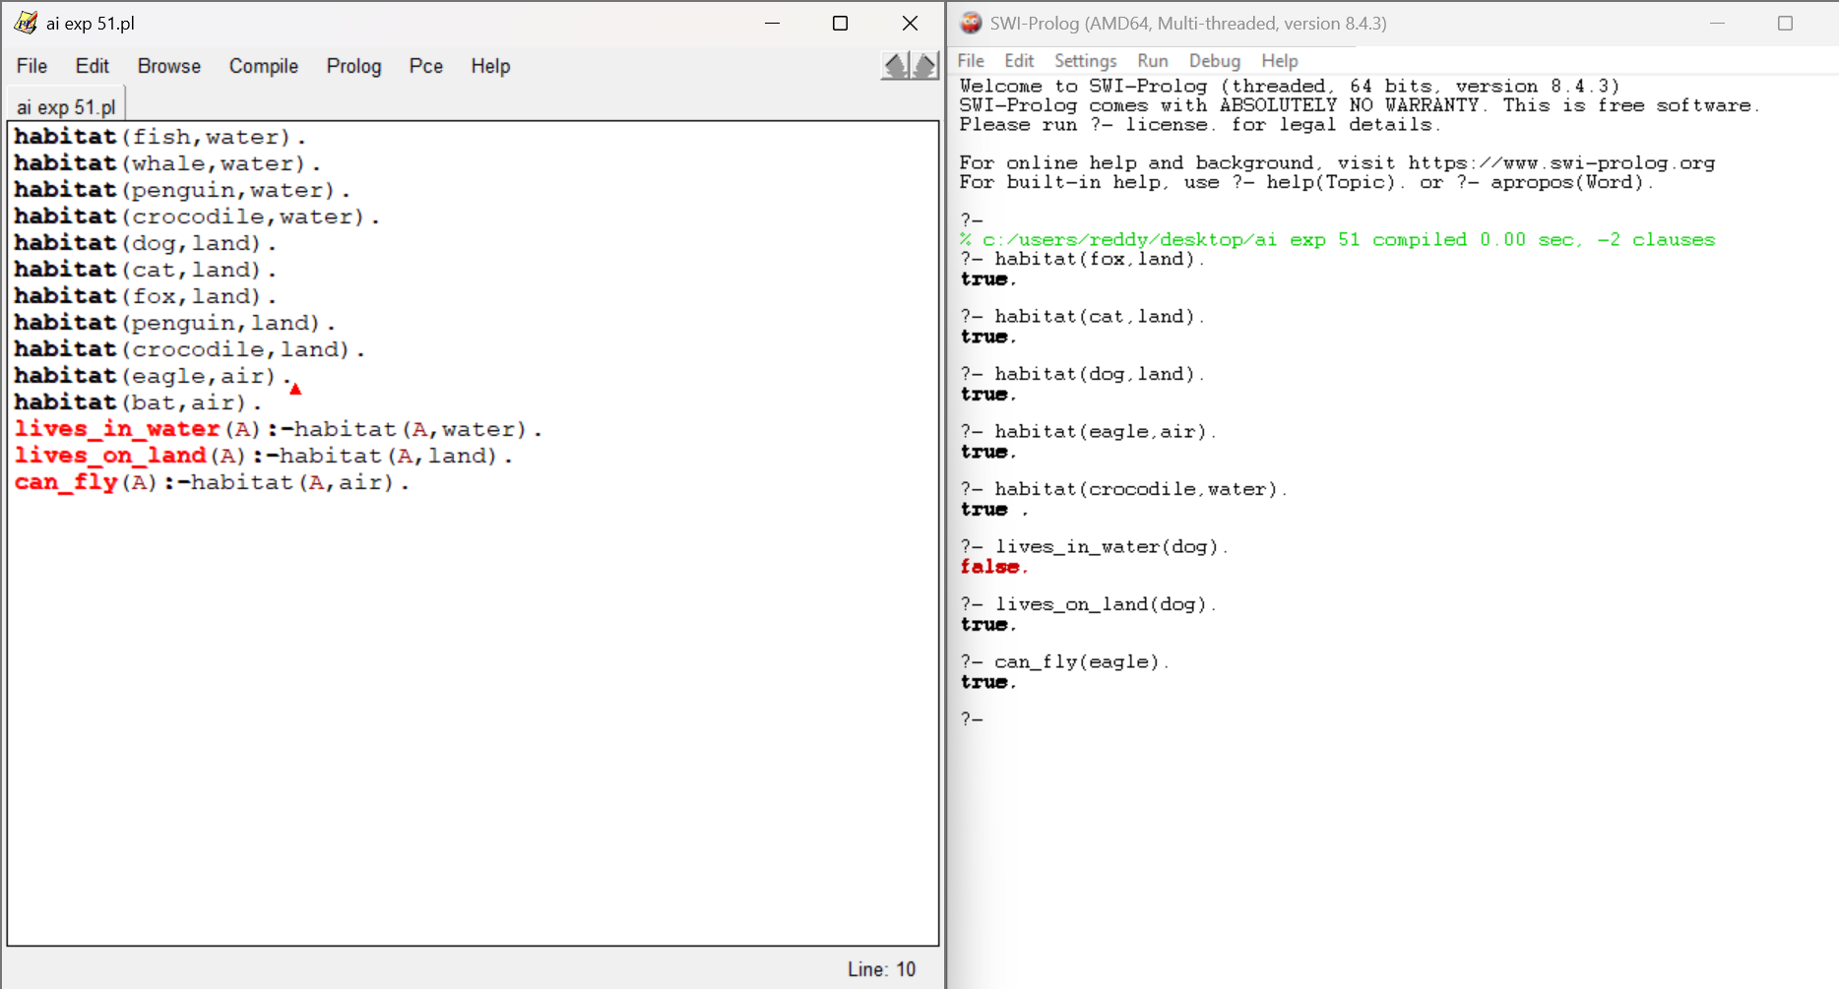
Exp-52: - Medical Diagnosis
Code:
symptom(flu,cough).
symptom(flu,cold).
symptom(flu,body_ache).
symptom(malaria,chills).
symptom(malaria,fever).
symptom(malaria,headache).
symptom(typhoid,fever).
symptom(typhoid,abdominal_pain).
symptom(typhoid,headache).
has_symptom(P,S).
diagnose(P,D):-symptom(D,S),has_symptom(P,S).
Output:
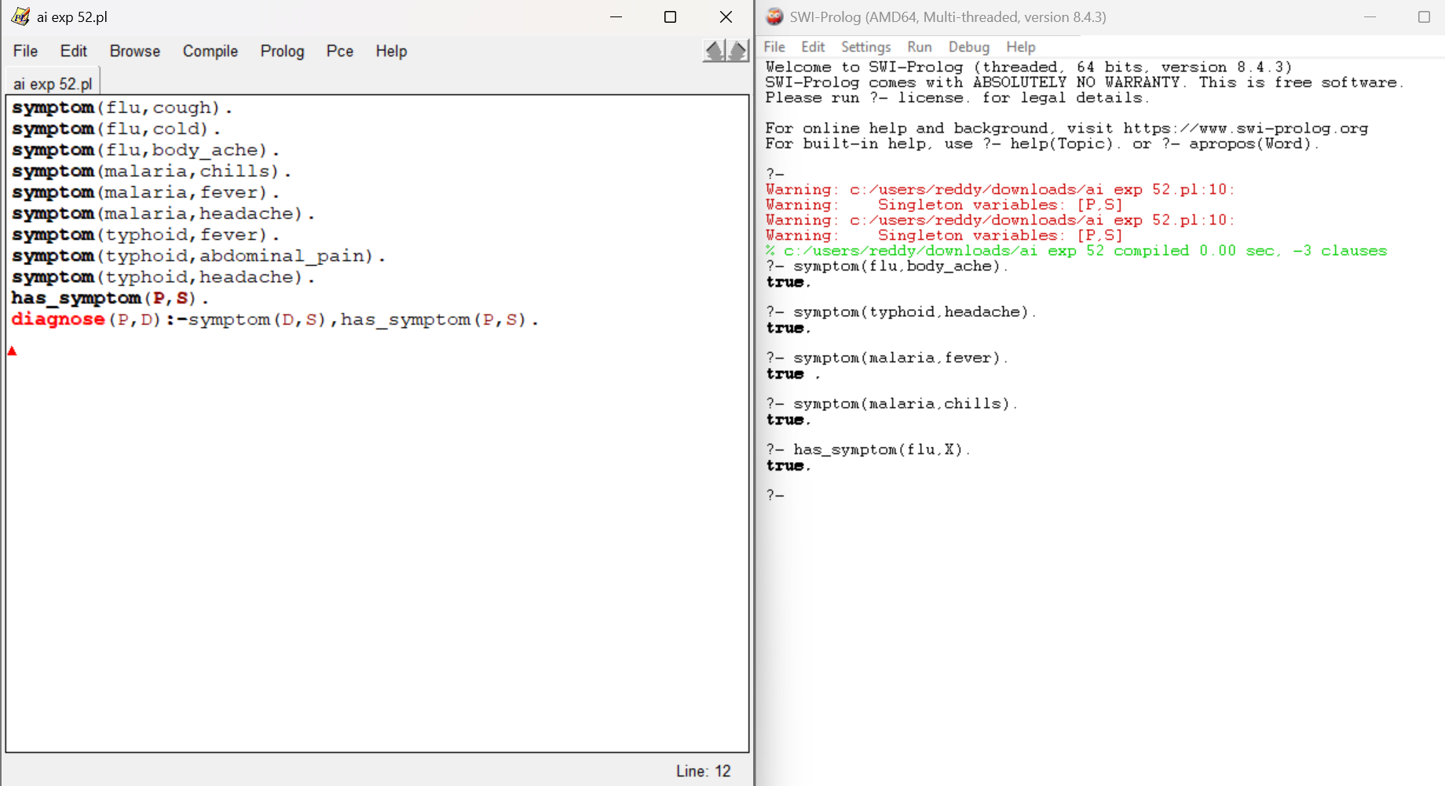
Exp-53: -Student Subject and Marks
Code:
enrolled(mary,chemistry).
enrolled(peter,biology).
enrolled(linda,physics).
enrolled(john,math).
enrolled(maths,mary).
enrolled(chemistry,peter).
enrolled(biology,linda).
enrolled(physics,john).
courses_of(Student,Course):-enrolled(Student,Course).
students_in(Course,Student):-enrolled(Student,Course).
Output:
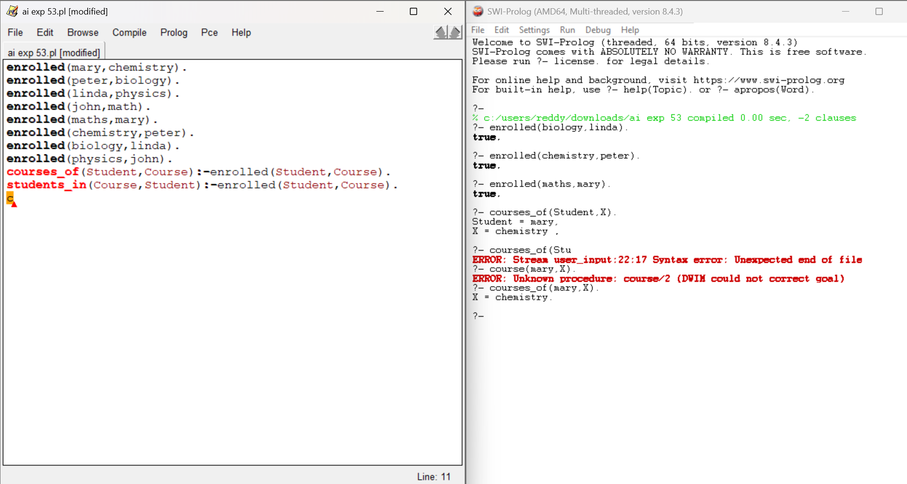
Exp-54: -Type of Vehicles and Fuels
Code:
type(car,road).
type(truck,road).
type(bike,road).
type(bus,road).
wheels(car,4).
wheels(truck,6).
wheels(bike,2).
wheels(bus,4).
fuel(car,petrol).
fuel(bike,petrol).
fuel(truck,diesel).
fuel(bus,diesel).
is_car(X):-type(X,road),wheels(X,4).
is_bike(X):-wheels(X,2).
is_heavy(X):-fuel(X,diesel).
Output:
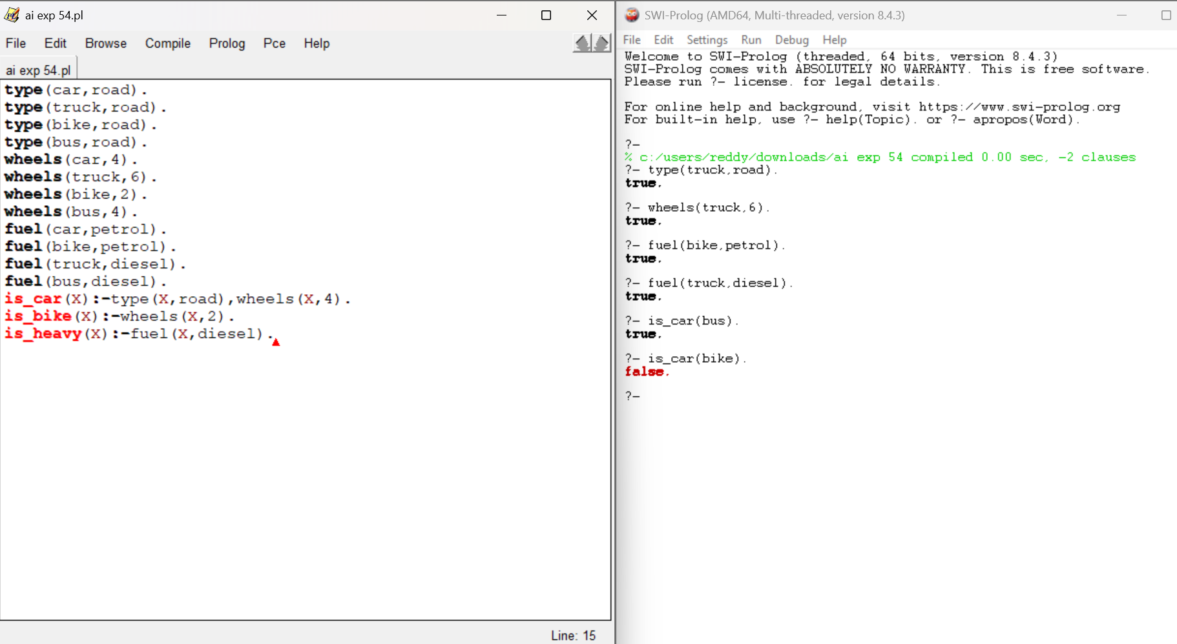
Exp-55: -Veg and Nonveg Items
Code:
dish(paneer,veg,spicy).
dish(salad,veg,mild).
dish(biryani,nonveg,spicy).
dish(chicken_curry,nonveg,spicy).
dish(idli,veg,mild).
dish(fish_fry,nonveg,spicy).
recommend(V,S,D):-dish(D,V,S).
Output:
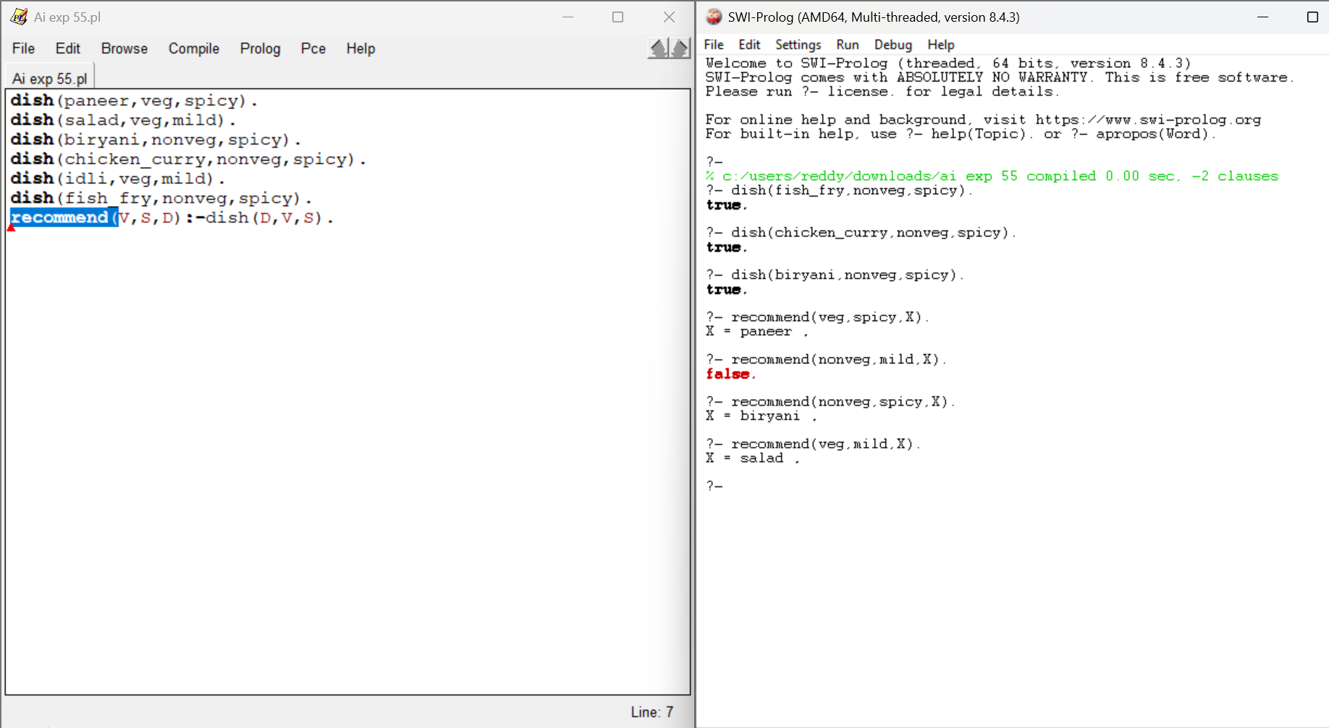
Exp-56: - Trust & Reputation Propagation System
trust(a, b, 0.80).
trust(b, c, 0.70).
trust(c, d, 0.90).
trust(a, d, 0.40).
propagated_trust(X, Y, T) :-
trust(X, Y, T).
propagated_trust(X, Y, T) :-
trust(X, Z, T1),
propagated_trust(Z, Y, T2),
T is T1 * T2
best_trust(X, Y, BestT) :-
indall(T, propagated_trust(X, Y, T), List),
max_list(List, BestT).
trust_path(X, Y, T) :-
propagated_trust(X, Y, T).
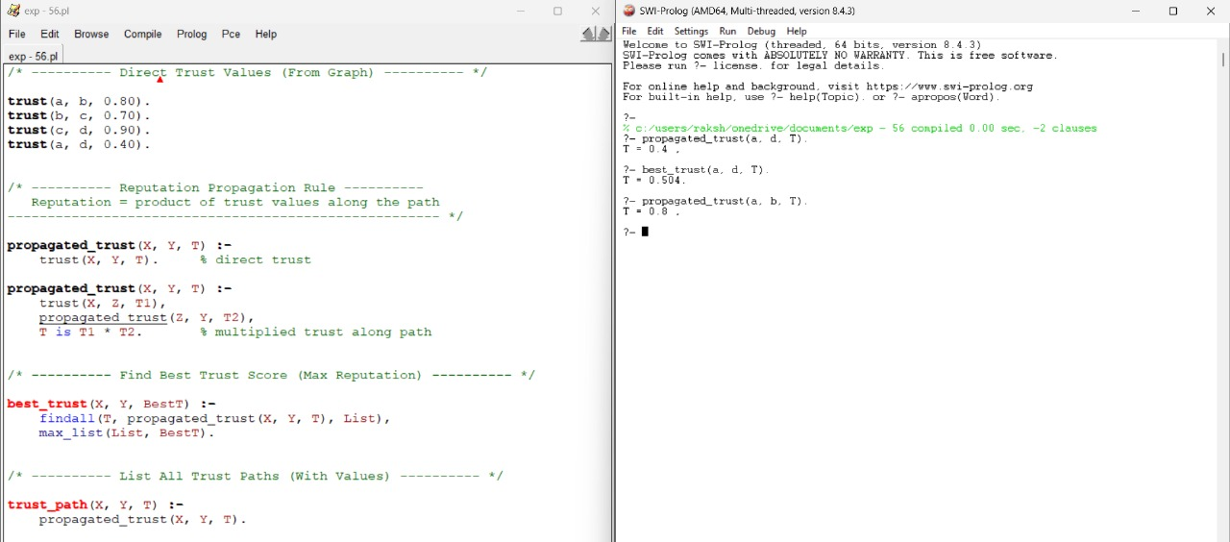
Exp-57: - Backward Chaining for Voting Eligibility
Code:
age(john, 25).
age(mary, 17).
age(alex, 19).
age(tina, 30).
age(george, 40).
citizen(john).
citizen(mary).
citizen(alex).
citizen(tina).
criminal_record(mary).
is_adult(Person) :-
age(Person, Age),
Age >= 18.
has_citizenship(Person) :-
citizen(Person).
not_disqualified(Person) :-
+ criminal_record(Person).
eligible_to_vote(Person) :-
is_adult(Person),
has_citizenship(Person),
not_disqualified(Person).
Output:
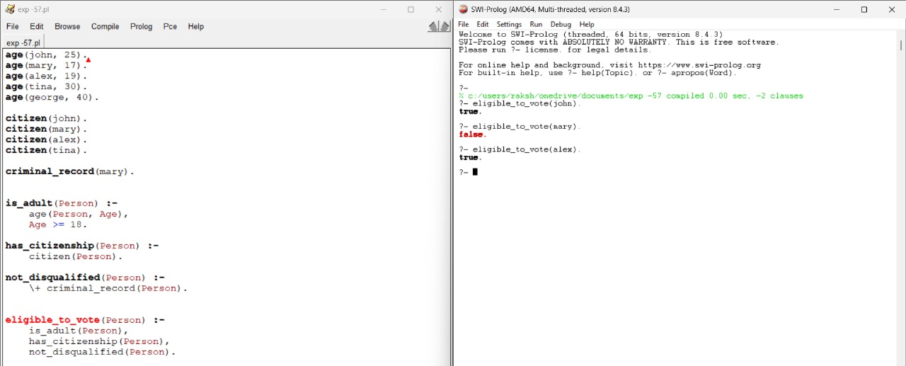
Exp-58: - Semantic Network Representation of Animal Hierarchy
Code:
is_a(sparrow, bird).
is_a(eagle, bird).
is_a(penguin, bird).
is_a(bird, animal).
is_a(whale, mammal).
is_a(mammal, animal).
isa_transitive(X, Y) :-
is_a(X, Y).
isa_transitive(X, Y) :-
is_a(X, Z),
isa_transitive(Z, Y).
is_descendant(X, Y) :-
isa_transitive(X, Y).
ancestor_of(X, Ancestor) :-
isa_transitive(X, Ancestor).
Output:
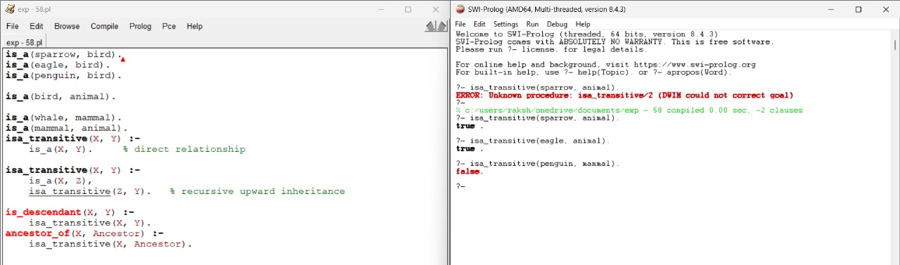
Exp-59: - Argumentation Framework & Acceptance Checking
attacks(a, b).
attacks(b, c).
attacks(c, a).
attacks(d, c).
attacked_by(X, Y) :-
attacks(Y, X).
defended(X) :-
\+ attacked_by(X, _).
defended(X) :-
attacked_by(X, Attacker),
attacks(Defender, Attacker),
X \= Defender.
accepted(X) :-
defended(X).
rejected(X) :-
attacked_by(X, _),
\+ defended(X).
Output:
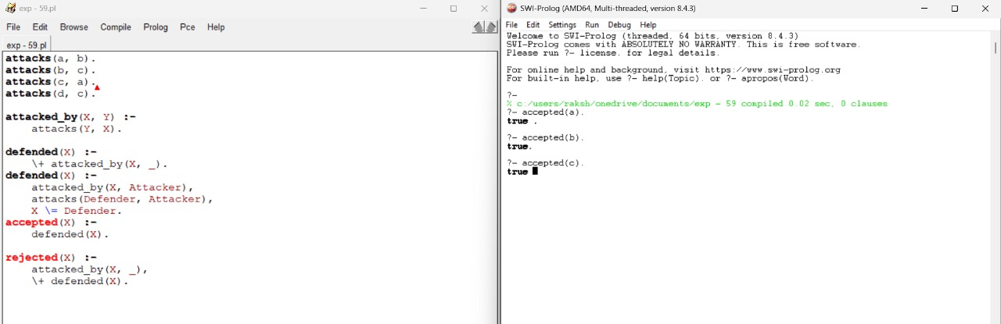
Exp-60: -Frames with Inheritance (Car, Electric Car, Hybrid Car)
Code:
frame(car, [
has_wheels,
uses_fuel
]).
frame(electric_car, [
uses_battery,
no_emissions
]).
frame(hybrid_car, [
uses_fuel,
uses_battery,
low_emissions,
has_engine
]).
parent(electric_car, car).
parent(hybrid_car, car).
has_attribute(Frame, Attribute) :-
frame(Frame, Attributes),
member(Attribute, Attributes).
has_attribute(Frame, Attribute) :-
parent(Frame, Parent),
has_attribute(Parent, Attribute).
Output:
